Alt Persons are to search Manv items are not

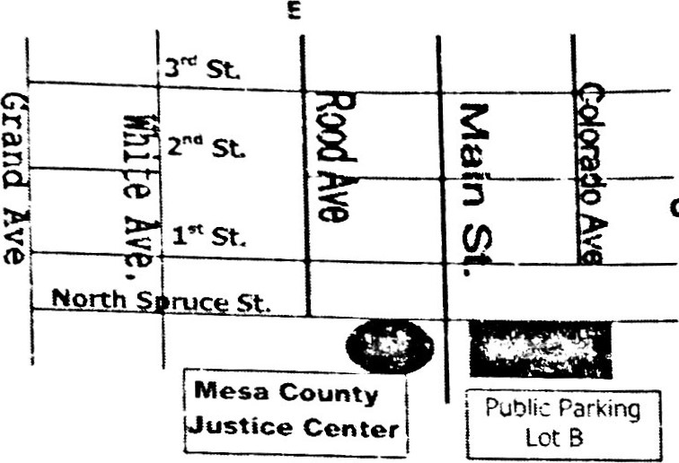cn

The Mesa County Justice Center is located at 125 North



.t.:ruce Street, one block west of 1 e Street at the intersection



*f Main Street and North Spruce Street. A free public

{at-king lot (Lot B) IS located acrcss Main Street from the stice Center,

|  |  |
| --- | --- |
| IMPORTANT - PLEASE READ  PLEASE READ CAREFULLY You have been summoned for Jury Service on MONDAY ,For fastest response DECEMBER 11 , 2017, as explained aboveMesaj ury@j udicial . Because trials often cancel at the last moment youhttp://mesa.coj ury must call *257-3693* * after 4 p.m. on DECEMBER 8 toyour request in wr listen to reporting instructions (includingsummons and includ appearance time and free parking info) OR go tofor the court's re http: //mesa.cojury . org for reporting970-257-8767; OR 3) information. Reporting info also available Sat/ Sun.bring children to j REQUESTS FOR POSTPONEMENT OR DISQUALIFICATION MUST BE  SUBMITTED  AT  LEAST | |
| |  | | --- | | SUMMONS FOR TRIAL  JUROR NUMBER: 1636  APPEARANCE DATE: MONDAY, DECEMBER 11, 2017  TIME:  LOCATION: MESA COUNTY JUSTICE CENTER  JURY ASSEMBLY ROOM (3RD FLOOR)  125 NORTH SPRUCE STREET  GRAND JUNCTION, CO 81501  JURY COMMISSIONER: ROSE ANNE KELLEY  TELEPHONE NUMBER: SEE BLUE BOX | | | KEEP THIS SUMMONS AND BRING IT WITH YOU ON YOUR APPEARANCE DATE |   JUROR SERVICE Mesa Count | •JURORS  JUROR 1636  CODE: 121117 39 81911-1636  JOSEPH JAMES WEBB |
|
|  |

such as weapons, Sharo objects, and mace for exarnole.

# THE ONE DAY OR ONE TRIAL JURY SYSTEM

Colorado law makes jury service as convenient as possible for the majority of our citizens. You have been randomly selected for jury duty. You should be prepared to serve at least one full day or, if selected for a trial, the duration of that trial. Most jurors complete their jury duty in one day. For those who are selected, the average length of a jury trial is three days. An explanation of payment for both employed and unemployed jurors can be found inside this summons. To preserve the fairness of jury selection, there are no occupational, economic, or upper age limit exemptions, from jury service.



|  |
| --- |
| MESA COUNTY |

1636 121117 39 81911-1636

## JS-OI (8-07)